Monday 23.02.2026

This message relates exclusively to our Clase site (our Penlan and Dyfatty sites are not affected)

Dear parent/carer

During the half-term holidays ground testing results in outdoor areas at our school found soil contamination in a small number of locations.

Some of these showed a higher than usual presence of the heavy metal lead. This may be due to area’s historic industrial past.

As a precaution and due to the needs of pupils who attend our school, we have been advised to place these areas off limits while further tests and potential remedial work is undertaken.

Fencing has been erected to prevent access to the affected areas.

Unaffected outdoor areas at the school remain fully open and this will hopefully keep any disruption to your child’s outdoor learning and play to a minimum. The school also operates effective hand hygiene procedures.

The wellbeing of all our pupils is always our number one priority and this precautionary action has been taken to help reassure you of that.

We will of course continue to keep you informed and if you have any questions, please do not hesitate to contact us.

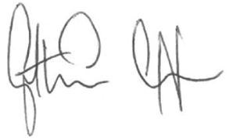

Gethin Sutton
Headteacher

